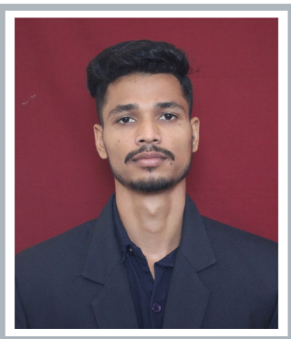

**Name:**

**Sipun kumar biswal**

**Master of Computer Applications (MCA)**

Email:

22

mca048.sipunkumarbiswal@giet.edu

Phone:

7077403766

LinkedIn:

<https://www.linkedin.com/in/sipun-kumar-biswal-294a3a285/>

-294a3a285/

**Career Objective**

A fast learner eager to hold a data analyst position, bringing the analytical skills, extensive knowledge of operations, and abilities to help the company and clients achieve their goals.

**Educational Qualifications**

|  |  |  |  |  |
| --- | --- | --- | --- | --- |
| **Degree** | **Year of Passing** | **Institute** | **Board** | **Percentage/CGPA** |
| **MCA** | Continuing.. | GIET UNIVERSITY | GIET UNIVERSITY | **Till now 7.38CGPA** |
| **B.Sc. Chemistry** | 2022 | Chandabali college chandabali | F.M UNIVERSITY | **6.70 CGPA** |
| **+2 Science** | 2018 | Nabaghana college  Nabaghana,karanjadia | CHSE | **52.33%** |
| **10th** | 2016 | Karanjadia high school ,mallikadeipur | BSEO | **67%** |

# Certifications:-

Post Graduation Diploma in Computer Application(PGDCA) Bootcamp create Facebook login using HTML & CSS

# Achievements and Extracurricular activities:-

* Under Officer(SUO) in NAVAL NCC
* Senior Volleyball champion at GIET university

# General & Technical Skills:-

* JAVA (Core java)
* C language
* HTML , CSS , JAVASCRIPT
* MY SQL
* PYTHON

**Projects:-**

* customer relationship management

Using JAVA,ADVANCED JAVA,CSS,JAVASCRIPT,BOOTSTRAP

# Personal Portfolio

Using HTML,CSS,JAVASCRIPT

# ATM Features

Using Core java,Jdbc,Sql

**Personal Details**

|  |  |
| --- | --- |
| Date of Birth | 05/09/2000 |
| Gender | Male |
| Father's Name | Sudam biswal |
| Address | At:-Gopalpur, Po:-Naikanidigi, Dist:-Bhadrak , Pin:-756164,State:-Odisha |
| Alternate phone number | 8260271117 |
| Language Known | ODIA , HINDI , ENGLISH |
| Interests & Hobbies | Volleyball , Running,Swimming |

Signature:-

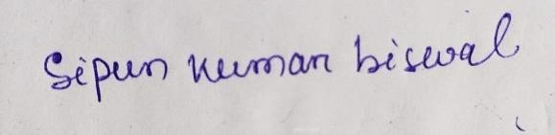

Place:- Gunupur

Date: **21/June/2023**